Student Name: Muhammad Shoaib Khan  
NAVTTC Database Assignment  
Section: A

**Procedures Assignment**

CREATE TABLE `db_assignment_1`.`teacher_table` (

`teacher_id` INT NOT NULL,

`teacher_name` VARCHAR(45) NULL,

`tea_father_name` VARCHAR(45) NULL,

`teacher_salary` INT NULL,

`avg_salary` INT NULL DEFAULT '25942',

PRIMARY KEY (`teacher_id`));

INSERT INTO `db_assignment_1`.`teacher_table` (`teacher_id`, `teacher_name`, `tea_father_name`, `teacher_salary`) VALUES ('001', 'Teacher1', 'Tea_fat_01', '50000');

INSERT INTO `db_assignment_1`.`teacher_table` (`teacher_id`, `teacher_name`, `tea_father_name`, `teacher_salary`) VALUES ('002', 'Teacher2', 'Tea_fat_02', '25600');

INSERT INTO `db_assignment_1`.`teacher_table` (`teacher_id`, `teacher_name`, `tea_father_name`, `teacher_salary`) VALUES ('003', 'Teacher3', 'Tea_fat_03', '46000');

INSERT INTO `db_assignment_1`.`teacher_table` (`teacher_id`, `teacher_name`, `tea_father_name`, `teacher_salary`) VALUES ('004', 'Teacher4', 'Tea_fat_04', '32000');

INSERT INTO `db_assignment_1`.`teacher_table` (`teacher_id`, `teacher_name`, `tea_father_name`, `teacher_salary`) VALUES ('005', 'Teacher5', 'Tea_fat_05', '18000');

INSERT INTO `db_assignment_1`.`teacher_table` (`teacher_id`, `teacher_name`, `tea_father_name`, `teacher_salary`) VALUES ('006', 'Teacher6', 'Tea_fat_06', '34000');

SELECT * FROM db_assignment_1.teacher_table;

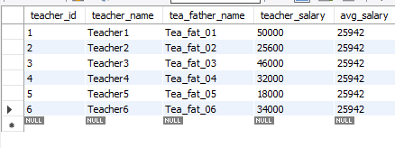

**1.Create store procedure with no parameter:**

DELIMITER //

create Procedure proc1()

begin

DECLARE X INT;

SET X=1;

SELECT * FROM teacher_table

WHERE teacher_id=X;

END //

DELIMITER ;

**Invoke Method:**

DELIMITER //

call proc1()

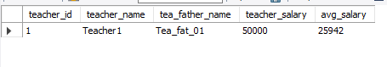

**2.Create store procedure with IN parameter (optional two or more parameters)**

DELIMITER //

CREATE PROCEDURE proc2(IN X INT, IN tname VARCHAR(255))

BEGIN

SELECT * FROM teacher_table

WHERE teacher_id=X AND teacher_name=tname;

END//

DELIMITER ;

**Invoke Method:**

DELIMITER //

call proc2(2, 'Teacher2')

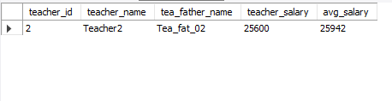

**3.Create store procedure with OUT parameter (optional two or more parameters)**

DELIMITER //

CREATE PROCEDURE proc3(OUT totalTeachers INT)

BEGIN

SELECT COUNT(teacher_id) INTO totalTeachers FROM teacher_table;

END//

DELIMITER ;

**Invoke Method:**

DELIMITER //

call proc3(@totalTeach)

SELECT @totalTeach//

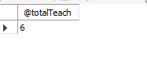

**4.Create store procedure with INOUT parameter ()**

DELIMITER //

CREATE PROCEDURE proc4(IN name VARCHAR(255), OUT totalTeachers INT, INOUT salary INT)

BEGIN

SELECT * FROM teacher_table

WHERE name=teacher_name;

UPDATE teacher_table

SET teacher_salary=salary

WHERE name=teacher_name;

SELECT COUNT(teacher_id) INTO totalTeachers FROM teacher_table;

END//

DELIMITER ;

**Invoke Method:**

DELIMITER //

SET SQL_SAFE_UPDATES = 0;

SET @teacher_salary=70000

CALL proc4('teacher3',@tol,@teacher_salary)

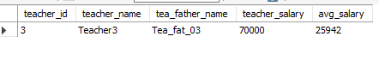

**5. USE IF ELSEIF, ELSE**

DELIMITER //

CREATE PROCEDURE SalaryStatus(IN emp_id INT, OUT sal_status VARCHAR(255))

BEGIN

DECLARE curr_sal DECIMAL(8,2);

DECLARE avrg_sal DECIMAL(8,2);

SELECT AVG(teacher_salary) INTO avrg_sal FROM teacher_table;

SELECT teacher_salary INTO curr_sal FROM teacher_table

WHERE emp_id=teacher_id;

IF curr_sal < avrg_sal THEN

SET sal_status='Less than Average salary';

ELSEIF curr_sal=avrg_sal THEN

SET sal_status='Equal to average salary';

ELSEIF curr_sal>avrg_sal THEN

SET sal_status='Greater than average salary';

END IF;

END//

DELIMITER ;

**Invoke Method:**

DELIMITER //

SET SQL_SAFE_UPDATES = 0;

CALL SalaryStatus(3,@sal_status)//

SELECT @sal_status;

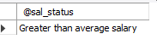

**6. Drop any one store procedure**

DROP PROCEDURE IF EXISTS display;